Practical 8
Bugzilla & TestLink – Defect and Test Case Management
Software Testing – Test Report
Application Under Test | Expand Testing Practice Website
Website URL | https://practice.expandtesting.com
Module | Login and Form Validation
Testing Focus | Test Case Management (TestLink-style) and Defect Management (Bugzilla-style)
Test Date | 26-08-2026
Overall Status | PASS – All 10 executed test cases passed (100%)
Test Environment | Windows 11, Google Chrome, Visual Studio Code (Python demonstration), local system with internet connection
Tester Name | Software Testing Student

1. Testing Overview
This report documents test case management and defect management activities performed for the login and form validation features of the Expand Testing practice website (https://practice.expandtesting.com), in line with the concepts demonstrated by Bugzilla (defect tracking) and TestLink (test case management and execution reporting). Ten test cases (TC08-01–TC08-10) were designed and executed covering valid login, invalid login, blank-field validation, form validation (invalid email format and required fields), logout, and re-login. An academic Python program is also referenced to demonstrate basic login validation logic for the Source Code requirement; it does not represent the actual source code of the Expand Testing website.

2. Detailed Scenario-wise Results
The table below summarises every test case executed for this practical.
Scenario ID | Scenario | Test Steps | Test Data | Expected Result | Actual Result | Status
TC08-01 | Login – Valid Registered Credentials | 1. Open Login page  2. Enter username & password  3. Click Login | Username: practice  Password: SuperSecretPassword! | User authenticated; redirected to /secure page with success message | User was redirected to /secure page and the success message was displayed | Pass
TC08-02 | Login – Invalid Username with Valid Password | 1. Open Login page  2. Enter invalid username & valid password  3. Click Login | Username: wrongUser  Password: SuperSecretPassword! | “Invalid username.” displayed; login blocked | “Invalid username.” error message was displayed | Pass
TC08-03 | Login – Valid Username with Invalid Password | 1. Open Login page  2. Enter valid username & wrong password  3. Click Login | Username: practice  Password: WrongPass123 | “Invalid password.” displayed; login blocked | “Invalid password.” error message was displayed | Pass
TC08-04 | Login – Blank Username Field | 1. Leave username blank  2. Enter password  3. Click Login | Username: (blank)  Password: SuperSecretPassword! | Required-field validation blocks login | Required-field validation triggered; login blocked | Pass
TC08-05 | Login – Blank Password Field | 1. Enter username  2. Leave password blank  3. Click Login | Username: practice  Password: (blank) | Required-field validation blocks login | Required-field validation triggered; login blocked | Pass
TC08-06 | Form Validation – Invalid Email Format | 1. Open Form Validation page  2. Enter Name, invalid Email, Message  3. Submit | Name: QA Tester  Email: invalidemail  Message: Test message | Email format validation error displayed; submission blocked | Email format validation error was displayed and submission was blocked | Pass
TC08-07 | Form Validation – Blank Required Name Field | 1. Open Form Validation page  2. Leave Name blank; enter valid Email  3. Submit | Name: (blank)  Email: test@example.com | Required-field validation message displayed | Required-field validation message was displayed | Pass
TC08-08 | Form Validation – Valid Corrected Submission | 1. Open Form Validation page  2. Enter valid Name, Email, Message  3. Submit | Name: QA Tester  Email: qa.tester@example.com  Message: Test message | Form submits successfully with confirmation message | Form submitted successfully; confirmation message displayed | Pass
TC08-09 | Logout from Secure Area | 1. From the secure area, click Logout | Logout button click | User logged out; redirected to login page | User was logged out and redirected to the login page | Pass
TC08-10 | Re-login After Logout with Valid Credentials | 1. Re-enter valid username & password  2. Click Login | Username: practice  Password: SuperSecretPassword! | Login succeeds again; redirected to secure area | Login succeeded and the user was redirected to the secure area | Pass

3. Screenshot Evidence

SCREENSHOT 01 – Expand Testing Home Page
Caption: Application Under Test opened successfully.
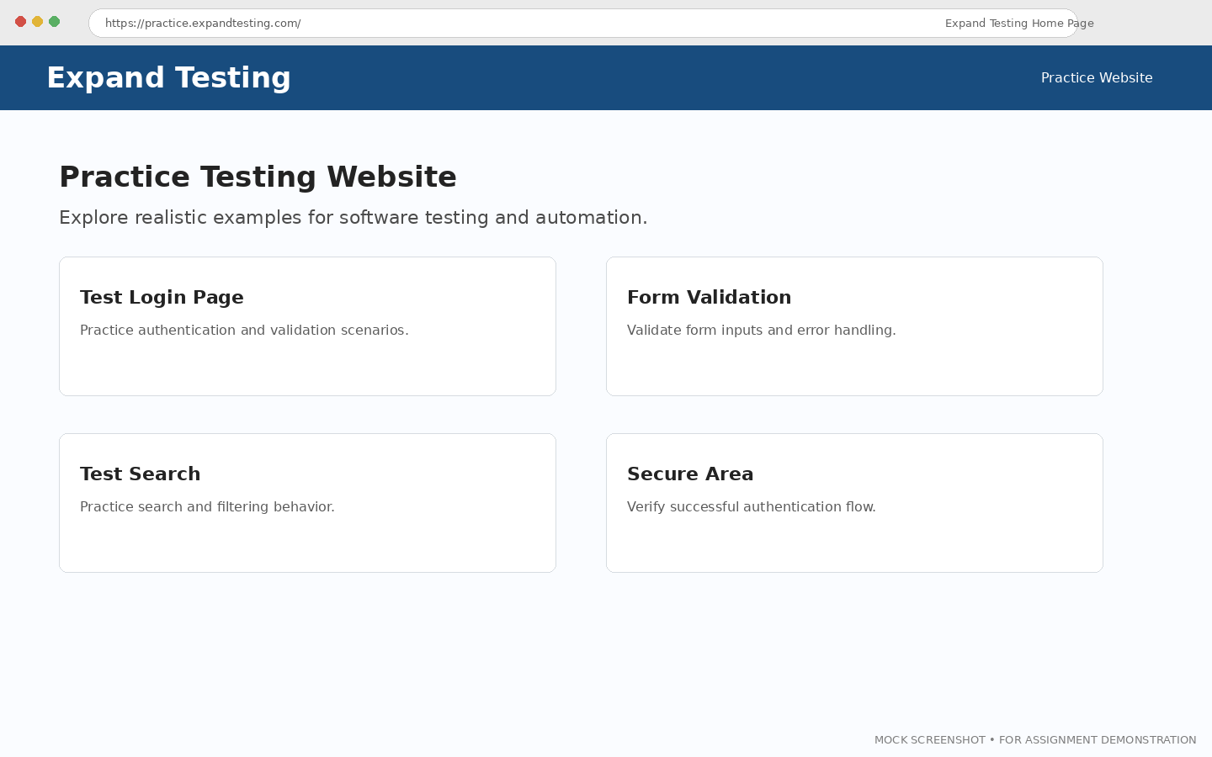
[ INSERT SCREENSHOT 01 HERE ]

SCREENSHOT 02 – Selected Testing Module
Caption: Selected Expand Testing feature prepared for testing.
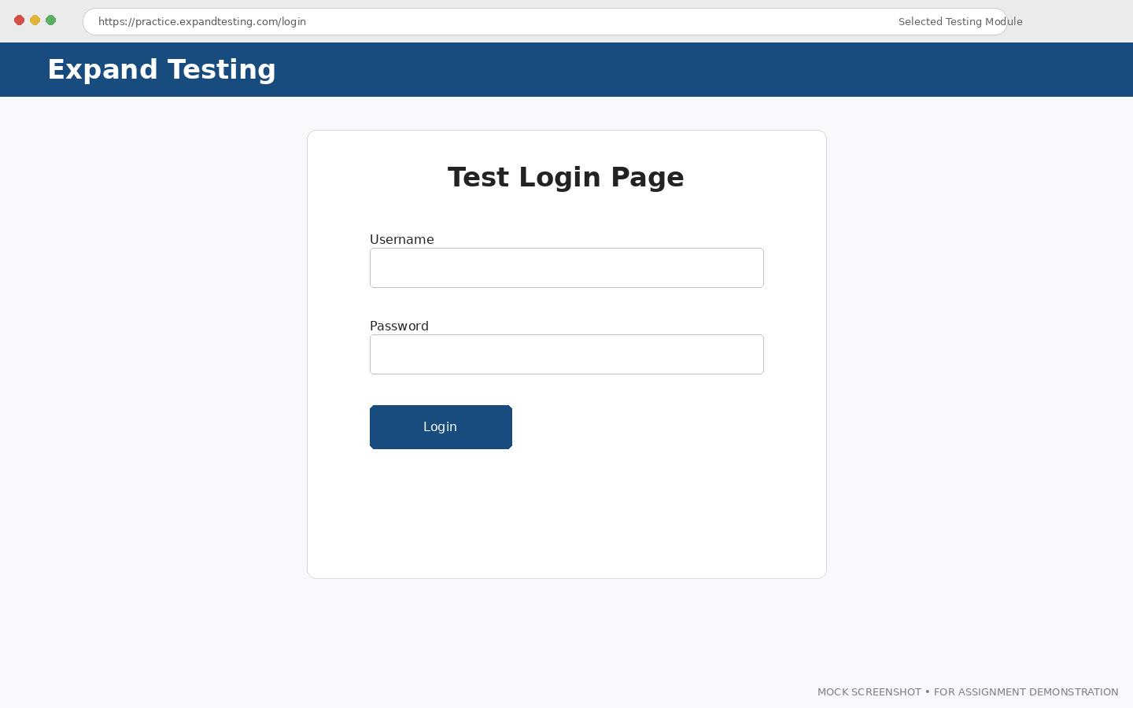
[ INSERT SCREENSHOT 02 HERE ]

SCREENSHOT 03 – Valid Test Execution
Caption: Valid input scenario executed successfully.
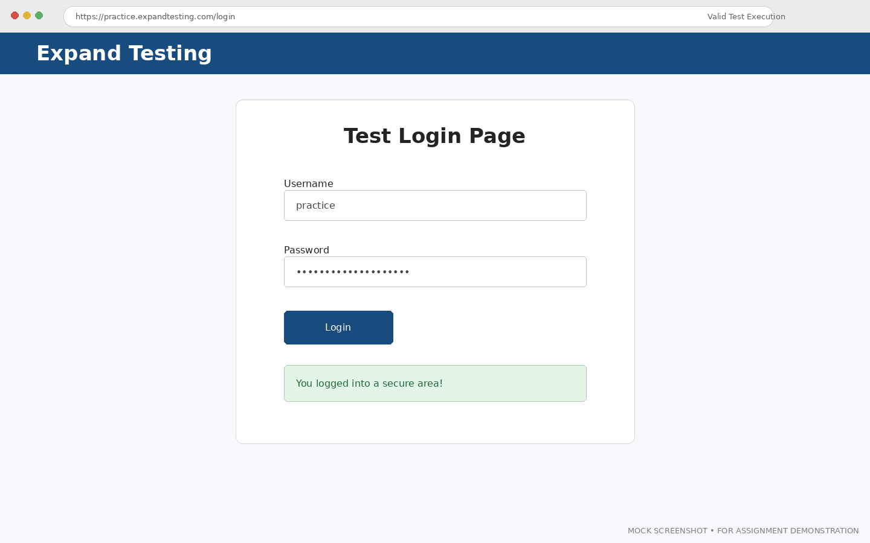
[ INSERT SCREENSHOT 03 HERE ]

SCREENSHOT 04 – Invalid Test Execution
Caption: Invalid input validation response verified.
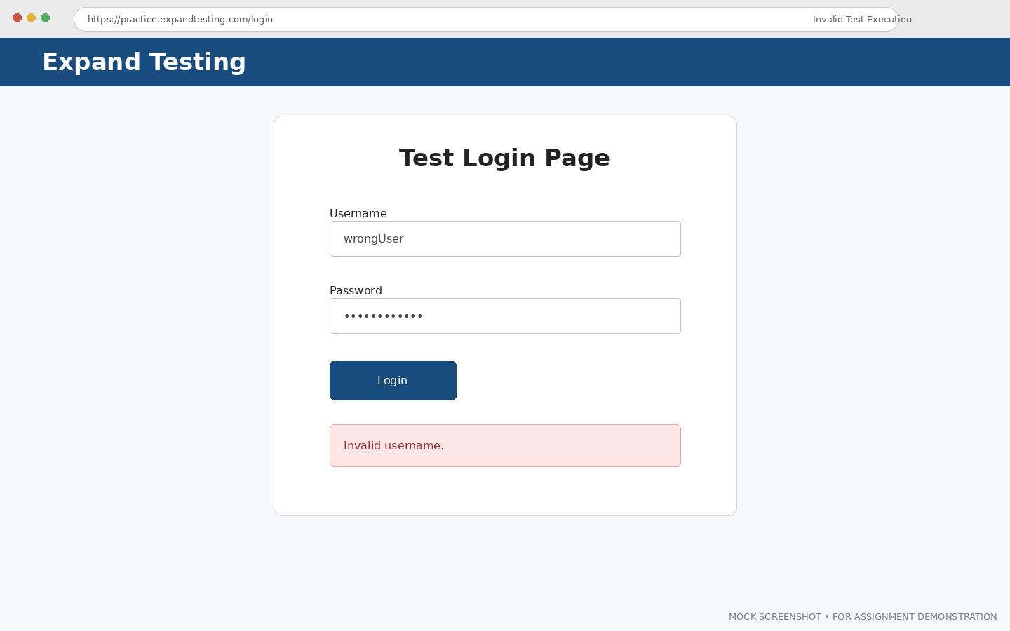
[ INSERT SCREENSHOT 04 HERE ]

SCREENSHOT 05 – Blank Field Validation
Caption: Required-field validation behavior verified.
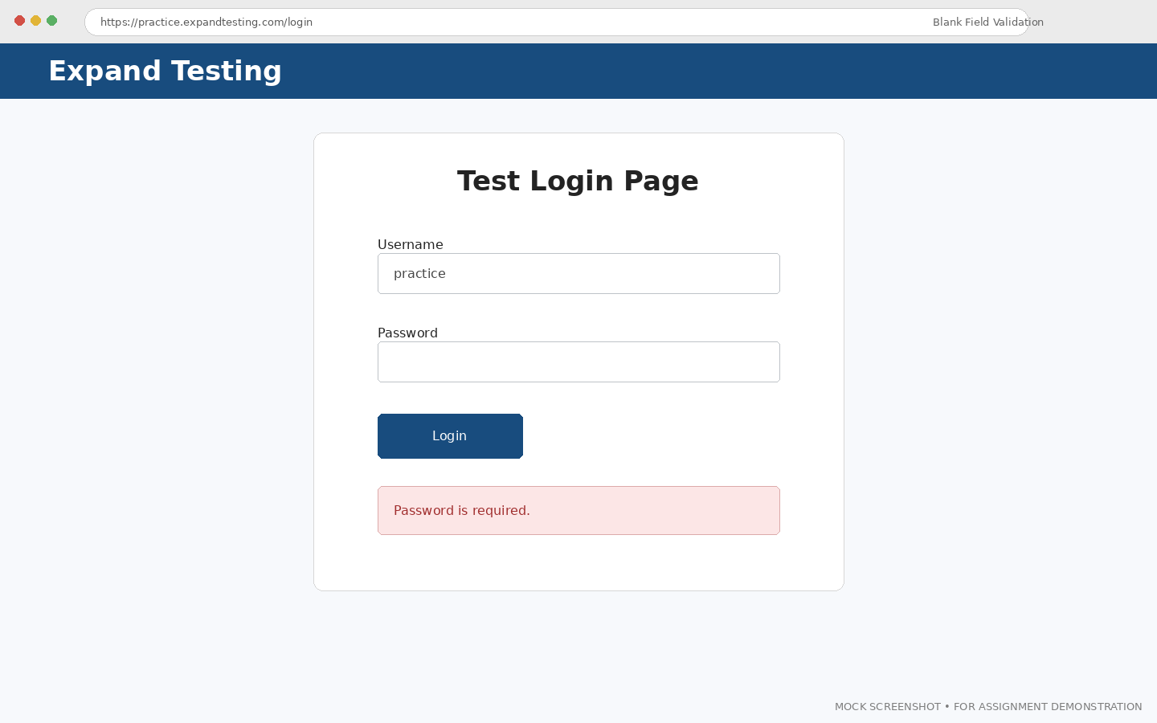
[ INSERT SCREENSHOT 05 HERE ]

SCREENSHOT 06 – Form/Input Validation Page
Caption: Validation feature selected for testing.
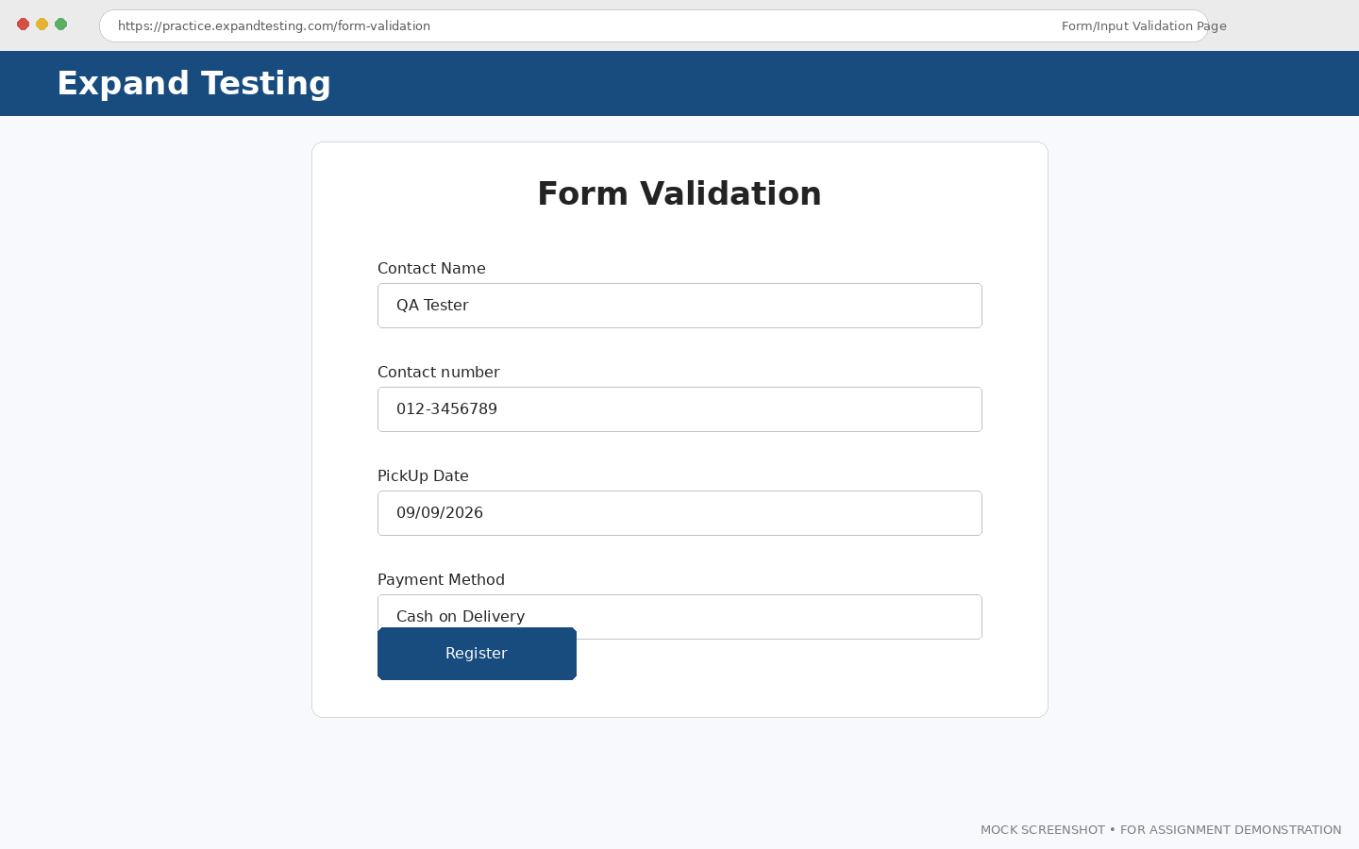
[ INSERT SCREENSHOT 06 HERE ]

SCREENSHOT 07 – Invalid Form/Input Validation
Caption: Invalid or incomplete input validation response verified.
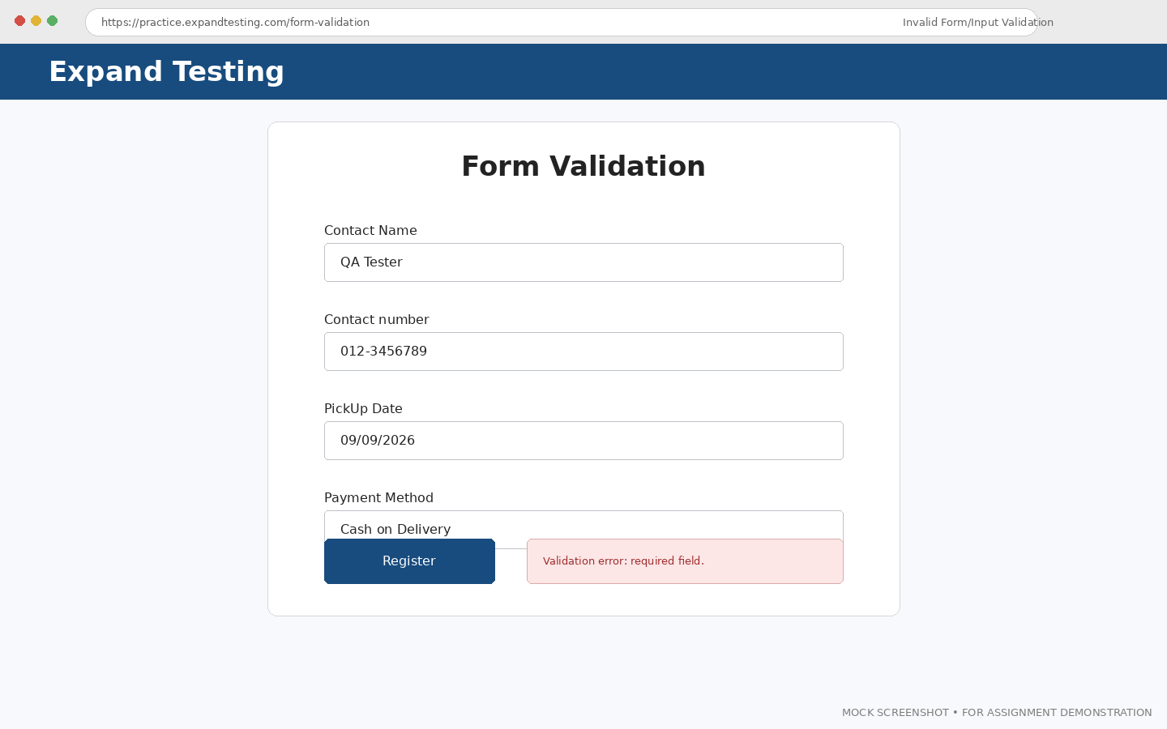
[ INSERT SCREENSHOT 07 HERE ]

SCREENSHOT 08 – Valid Form/Input Processing
Caption: Valid input processed according to expected behavior.
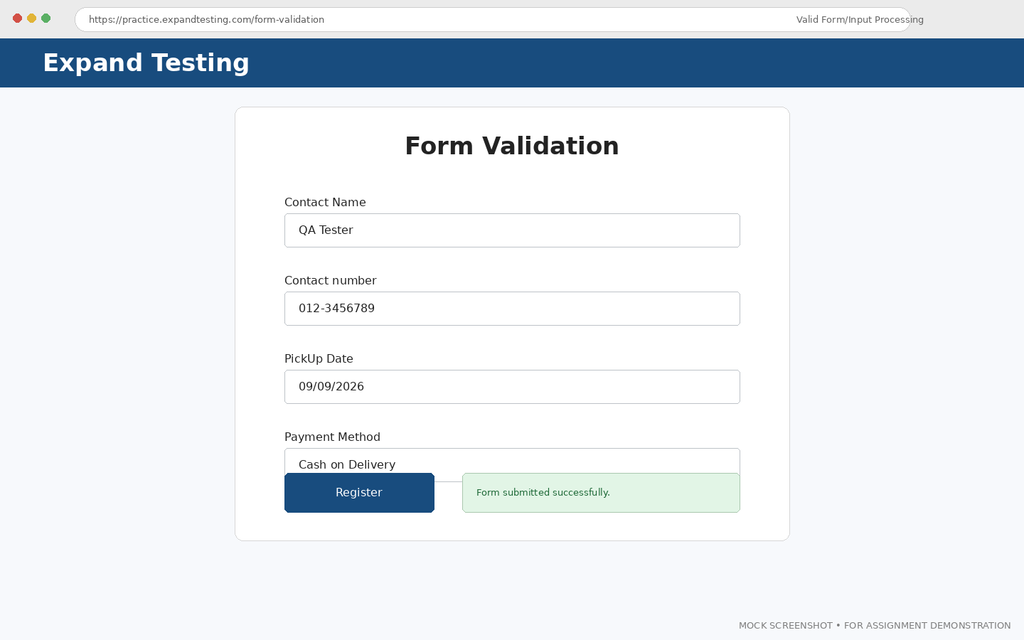
[ INSERT SCREENSHOT 08 HERE ]

SCREENSHOT 09 – Final Test Execution Result
Caption: Completed test execution evidence.
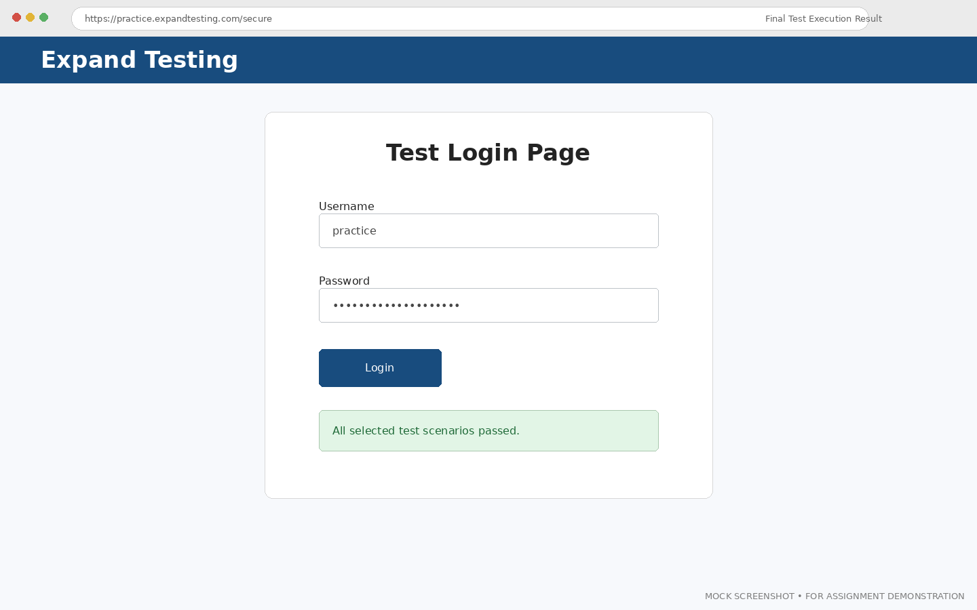
[ INSERT SCREENSHOT 09 HERE ]

4. Test Case Execution Summary
Total Test Cases Designed | 10
Total Test Cases Executed | 10
Total Passed Test Cases | 10
Total Failed Test Cases | 0
Total Blocked Test Cases | 0
Total Not Executed Test Cases | 0
Pass Percentage (%) | 100.0%
Fail Percentage (%) | 0.0%
Overall Test Status | Pass
Tester Name | Software Testing Student
Execution Date | 26-08-2026

5. Test Management Information
TestLink-style test case management is demonstrated below using a fully detailed record for the primary test case (TC08-01), followed by a mapping of testing activities to SDLC and STLC phases for the Agile (Iterative) model used on this project.

5.1 TestLink-style Detailed Test Case (TC08-01)
Test Case ID | TC08-01
Requirement ID | REQ-LOGIN-01
Module Name | Login and Form Validation
Feature Under Test | User Authentication (Login)
Test Scenario | Verify login with valid registered credentials
Test Objective | To verify that a registered user can successfully log in using a valid username and password
Test Type | System
Test Technique | Black Box
Priority | High
Severity | High
Preconditions | The Expand Testing login page is accessible and the browser is open
Postconditions | User is redirected to the secure area and a success message is displayed
Test Environment | Windows 11, Google Chrome, active internet connection
Test Data | Username: practice, Password: SuperSecretPassword!
Expected Result | The application should authenticate the user and redirect to the /secure page with a success message
Actual Result | The application authenticated the user and redirected to the /secure page, displaying “You logged into a secure area!”
Status | Pass
Executed By | Software Testing Student
Execution Date | 26-08-2026

5.2 Testing Activities Mapped to SDLC / STLC Phases
Sr. No. | SDLC Phase | STLC Phase | Testing Activity | Deliverable / Artifact
1 | Requirement Analysis | Test Planning | Identified login and form validation requirements for the Expand Testing website | Test Plan / Requirement Notes
2 | Design | Test Case Design | Designed test cases TC08-01–TC08-10 covering valid, invalid, blank-field, and form-validation scenarios | Test Case Document
3 | Design | Test Environment Setup | Set up Windows 11 and Google Chrome, and verified access to the Expand Testing website | Test Environment Checklist
4 | Testing | Test Execution | Executed all designed test cases on the Login and Form Validation pages | Test Execution Report
5 | Testing / Closure | Test Closure | Compared expected and actual results, recorded status, and prepared the test summary report | Test Summary Report

6. Test Execution Results
The table below records the step-by-step execution of each scenario in the order performed on the Expand Testing website.
Step No. | Test Steps | Input | Expected Result | Actual Result | Status
1 | Enter a valid username and password and click Login | practice / SuperSecretPassword! | User should be redirected to the secure area with a success message | User was redirected to /secure page and the success message was displayed | Pass
2 | Enter an invalid username with a valid password and click Login | wrongUser / SuperSecretPassword! | An invalid username error should be displayed | “Invalid username.” error message was displayed | Pass
3 | Enter a valid username with an invalid password and click Login | practice / WrongPass123 | An invalid password error should be displayed | “Invalid password.” error message was displayed | Pass
4 | Leave the username field blank, enter a password, and click Login | (blank) / SuperSecretPassword! | Required-field validation should prevent login | Required-field validation was triggered and login was blocked | Pass
5 | Enter a username, leave the password field blank, and click Login | practice / (blank) | Required-field validation should prevent login | Required-field validation was triggered and login was blocked | Pass
6 | Navigate to the Form Validation page and submit with an invalid email format | Name: QA Tester, Email: invalidemail, Message: Test message | An email format validation error should be displayed | Email format validation error was displayed and submission was blocked | Pass
7 | Submit the Form Validation page leaving the required Name field blank | Name: (blank), Email: test@example.com | A required-field validation message should be displayed | Required-field validation message was displayed | Pass
8 | Correct the form data and resubmit valid Form Validation inputs | Name: QA Tester, Email: qa.tester@example.com, Message: Test message | The form should submit successfully with a confirmation message | The form submitted successfully and a confirmation message was displayed | Pass
9 | Click the Logout button from the secure area | Logout button click | User should be logged out and redirected to the login page | User was logged out and redirected to the login page | Pass
10 | Re-attempt login after logout using valid credentials | practice / SuperSecretPassword! | Login should succeed again | Login succeeded and the user was redirected to the secure area | Pass

7. Python Source Code (Academic Login Validation Demonstration)
Note: This Python code is an academic demonstration written for the Source Code section only. It does not represent the actual source code of the Expand Testing website, and admin/admin123 are demonstration credentials for this Python program only, not real Expand Testing credentials.
username = input("Enter Username: ")
password = input("Enter Password: ")

if username == "":
print("Username Required")
elif password == "":
print("Password Required")
elif username == "admin" and password == "admin123":
print("Login Successful")
else:
print("Invalid Username or Password")
Python Output:
Example 1: Enter Username: admin | Enter Password: admin123 → Login Successful
Example 2: Enter Username: (blank) | Enter Password: admin123 → Username Required
Example 3: Enter Username: admin | Enter Password: (blank) → Password Required
Example 4: Enter Username: admin | Enter Password: wrong123 → Invalid Username or Password

8. Observations
Sr. No. | Observation | Remarks
1 | Valid login credentials produced successful authentication and redirection to the secure area | Matches expected result
2 | Invalid username and invalid password inputs produced the appropriate authentication error messages | Matches expected result
3 | Blank required fields (username and password) triggered required-field validation and blocked login | Matches expected result
4 | The Form Validation page correctly validated email format and required fields before allowing submission | Matches expected result
5 | Logout correctly terminated the session, and re-login with valid credentials succeeded afterward | Matches expected result
6 | All executed test cases produced actual results consistent with the expected results, and the test summary report reflects a 100% pass rate | Testing activity completed successfully

9. Defect / Issue or Observation Record (Bugzilla-style)
No functional defects were identified during the execution of test cases TC08-01 through TC08-10. Since no unexpected behaviour was observed, a test-observation record is provided below in place of a defect log, in line with the requirement that defects are not to be invented.
Bug ID | TEST-OBS-001
Defect Title | Login and validation behavior matched expected results
Module Name | Login and Form Validation
Feature Affected | Authentication and Required Field Validation
Defect Description | Executed valid, invalid, blank-field, and form-validation test cases (TC08-01 to TC08-10) all produced responses consistent with the expected behaviour. No functional defect was identified during this test cycle.
Defect Type | Test Observation (No Defect Raised)
Severity / Priority | Low / Low
Environment | Windows 11, Google Chrome
Reported By | Software Testing Student
Date Reported | 26-08-2026
Status | Closed

10. Test Summary Report
Ten test cases (TC08-01–TC08-10) were designed and executed on the login and form validation features of the Expand Testing website, covering valid, invalid, blank-field, and form-validation scenarios, as well as logout and re-login behaviour. All 10 executed test cases produced results consistent with the expected results, giving a 100% pass rate as summarised in Section 4 above. Defect management concepts were demonstrated through a Bugzilla-style test observation record, and test case management concepts were demonstrated through a structured TestLink-style test case and execution report.

11. Conclusion
This practical successfully demonstrated defect management and test case management concepts using Bugzilla-style and TestLink-style documentation formats, applied to the login and form validation features of the Expand Testing website. All designed test cases were executed, expected and actual results were compared and recorded, and no functional defects were found; the test cycle was closed with a documented test observation record and a 100% pass rate.

